What You Think
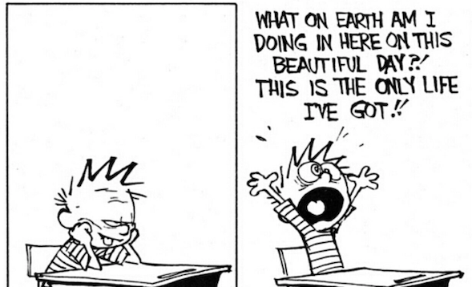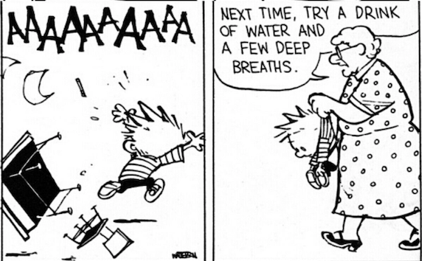
"Don't wait until you're in a crisis to come up with a crisis plan." ~ Phil McGraw

Food for Thought...
Crisis intervention is not a nine-to-five job. Crises tend to happen at inconvenient times when you least expect it.
Think about this statement as you complete the rest of the assignment. Make sure you follow "The Discussion Instructions."

The Prompt
The definition of a crisis is a disruption or breakdown in a person’s or family’s normal or usual pattern of functioning. Individual determination cannot disrupt a crisis. Also, although problems create stress, a problem is not a crisis if the family or individual is capable of finding a solution. So, a problem that of an individual or a family can resolve without outside intervention is not considered a crisis. Oftentimes, a crisis reveals who we are. Interventions that establish trust and provide reassurance, advice or a referral by the case worker may resolve such a problem. An emergency is a sudden, pressing necessity, such as when a life is in danger because of an accident, a suicide attempt, or family violence. An emergency requires immediate attention by law enforcement, CPS, or other professionals trained to respond to life-threatening events. If a situation can wait 24 to 72 hours for a response, without placing an individual or a family in jeopardy, it is a crisis not an emergency. Everyone has experiences that make them feel upset, disappointed, or fatigued. When these types of feelings are combined with certain life events or situations, they often lead to mounting tension and stress. There are several situations that causes people to experience emotional distress.Family, economic, and community situations and significant life events and natural disasters are common circumstances that hurl people into situations that are oftentimes unmanageable.

The Instructions
- Watch the "Crisis Counseling Skills" video here.
- Referencing the video, your textbook (pgs. 184-187), and other resources, discuss what a crisis is and how it is different from a problem.
- How might you, as a helping professional, best listen and respond to a client in crisis?
- Your submission word count is 300 - 500 words.

Note:

  - You must submit a post BEFORE you can see your classmates posts.
  - Your replies to your classmates should consist of a complete thought that contributes to the dialogue and furthers the discussion. "I agree" or "I like what you said" does not meet this criteria.
  - There are no right or wrong responses, so share your knowledge, insights and thoughts freely, but please be respectful to one another as you explore and discuss your ideas.
  - See the discussion rubric (in rubric link on the navigation bar) for grading criteria.
  - Discussion is due on Sunday November 7, 2021 at 11:59pm.

Click the Next ▶ button


"If you want to lift yourself up, lift up someone else." – Booker T. Washington

Food For Thought...
Being aware of unhealthy patterns of interaction. It is always a good time to begin disrupting unhealthy cycles and create healthier ones.
Think about this statement as you complete the rest of the assignment. Make sure you follow "The Discussion Instructions."

The Prompt
Co-occurring disorders means simultaneously having a mental health disorder and a substance use disorder. Although these illnesses are common, recurrent, and often serious, they are, nonetheless, treatable and manageable (SAMHSA.gov). The purpose of co-occurring disorders groups is to improve clients' health and wellness and help them achieve their full potential. In these co-occurring groups, clients' get to help others while continuing to help themselves. This is accomplished through providing a non-judgmental peer-supported setting. With proper support, people with co-occurring disorders are able to live healthy, happy lives in longterm recovery. Individuals who participate in a co-occurring disorder group can gain education about their condition, develop coping and life management skills, participate in mentoring of peers, and stay connected to vital resources. Additionally, co-occurring groups assuage feelings of loneliness and isolation, and provides a space to freely express feelings and acquire skills to live productively. It is little known that co-occurring disorders affect people from all walks of life and all age groups. (SAMHSA.gov). Reduced distress and the development of an insightful perspective of self acceptance and understanding is also an expected outcome. Members of the LGBTQI community have higher rates of diagnosable substance use disorders. More over, LGBTQI community members are twice as likely to have a mental health disorder. Researchers are just beginning to interrogate the depth of the myriad challenges of substance abuse and mental illness, i.e. co-occurring disorders, in the LGBTQI community.

The Instructions
- Watch the "Practice Demonstration - Groups for Clients with Co-Occurring" video here.
- Referencing the video, assigned articles, your textbook, and other resources discuss the benefits of groups on individuals from identified populations with a co-occurring disorder.
- What are the primary substance abuse and mental illness challenges faced byLGBTQI community? Why?
- Reference your source(s) of information in your reply.
- Respond to at least two of your classmates.
- Word count is 300 - 500 words.

Note:
- You must submit a post BEFORE you can see your classmates posts.
- Ideally, your response to your classmates should consist of a complete thought that contributes to the dialogue and furthers the discussion.
- There are no right or wrong responses, so share your knowledge, insights and thoughts freely, but please be respectful to one another as you explore and discuss your ideas.
- See the discussion rubric (in rubric link on the navigation bar) for grading criteria.
- Discussion is due on Sunday November 7, 2021 at 11:59pm.

Think About What You Think


“There is no communication that is so simple that it cannot be misunderstood.” ~ Luigina Sgarro

Food for Thought...
Eye rolling is one of the nonverbal signs that is pretty much always aggressive... 🙄 ...
Think about this statement as you watch the video and complete the rest of the assignment. Make sure you follow "The Assignment Instructions."

The Prompt
Listening is lost art that is desperately needed in the 21st century. In recent years, due to consumerism, social media, and cancel culturewe have become too focused on ourselves. This self centeredness affects the way we listen, or, more succinctly do not really listen. It is quite common for two people to act as if they are listening to each other, when they are actually waiting to talk primarily about him or herself. People have become so self-absorbed that there is a genuine lack of communication these days. People wrapped up in their own little world and no longer have the patience or just don't know how to listen. These are people who miss out on vitally important non-verbal cues and body language in communication. Most experts agree that at least 70% of all communication is nonverbal. So, when you are truly listening, you can connect with another person without saying a word. In that moment you are showing that person that what is important to them is also important to you, important enough that you actually paying attention. The most powerful way to connect to others is to listen. It is quite possible that the best gift you can give someone is your attention. As an aspiring clinician, you must learn how to listen.

The Instructions
- Watch the "Listen Better: 5 Essential Phrases for Active/Reflective Listening" video here.
- Referencing the video, your textbook (pgs. 165-172), and other resources, discuss the necessary listening skills required to be a good counselor.
- What is the biggest challenge to becoming an active listener? Why?

Your Assignment Response
- For this assignment, your response should be a minimum of two complete paragraphs.
- The assignment due date is Sunday, November 7, 2021 at 11:59 pm
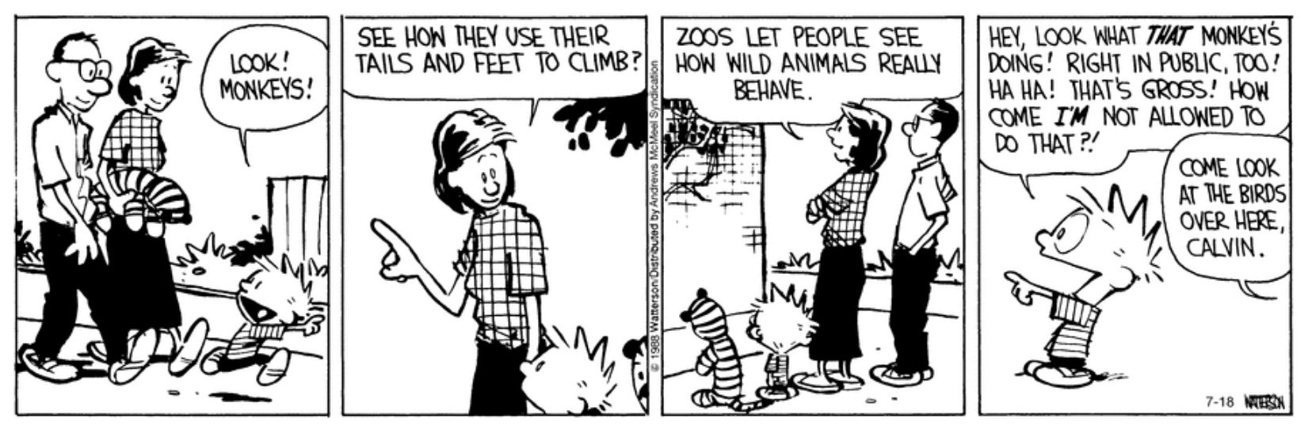 "Having no privacy, the homeless live their life in public view, so why do people treat them like animals instead of human beings who need housing and resources?" ~Ronald L. Moss, MSW
Consider This...
Like you, I know people with good jobs who drink, people who do drugs, and bosses who have tantrums and treat their subordinates like crap. If they were to become homeless, many of them would surely become mentally ill alcoholics and addicts.
Think about this question as you complete the assignment. Make sure you follow "The Assignment Instructions."

The Prompt
Bay Area Homelessness is something we witness daily. Many believe the homeless deserve what they are going through because they should pull themselves up by their bootstraps and get a job. Probably due to stigma, but also because the homeless tend to be misrepresented in the media, The common notion is that homelessness is somewhat a choice. But, very few of actually grapple with the notion of what it is really like to be homeless. and among homeless youth, the rates of substance use and mental illness is high. Meanwhile, one third of the homeless report having a mental illness. Clearly, mental illness is or becomes a challenge for the homeless. but overall, 68% said substance abuse is the reason that they are now unsheltered. Research shows that people with co-occurring disorders are the most vulnerable homeless population. Nonetheless, though once believed to be a population that is difficult to access and serve, the homeless, including those with a co-occurring disorder, do respond to services and benefit from substance abuse treatment and concurrent mental health services. With proper support, many have remained stable and in housing. The homelessness phenomenon is, apparently, much more nuanced than what we are being told.

The Instructions
- Watch the video "Homeless Man Shares the Harsh Reality of Skid Row" here.
- Referencing the videos, your textbook, and other resources discuss your perception of homelessness in your community and how alcohol, other drugs, and mental illness exacerbate the problems of the homeless.

Your Response
- Your response should be a minimum of two complete paragraphs.
- The assignment due date is Sunday, November 7, 2021 at 11:59pm.

Click the Next ▶ button
The most important thing to remember is it's not about you” ~ Dr. William Love

Food For Thought...
What America needs is a way to transition from a broken healthcare system that focuses on high cost, high tech interventions, after the onset of sickness, to a modern system that delivers high-touch, lower-cost, patient-centered coordinated care, with an emphasis on prevention in primary care before illness ensues.
Think about this statement as you complete the rest of the assignment. Make sure you follow "The Assignment Instructions."

The Prompt
A service coordinator's role is to manage and provide access to support services, provide case management services as needed and when requested, and initiate programs that provide resources and support the health and wellness of the target service population e.g. substance abusers in addiction treatment facility. Case managers are the main drivers of a service coordination team. They identify services, providers, and facilities throughout the continuum of care services, while ensuring that available resources are being used in a timely and cost-effective manner in order to obtain optimum value” for patient, payer, and provider. Effective client care coordination makes all the difference in a client’s health and wellness outcomes. Nonetheless, care coordination is not the same as service coordination. While a primary care physician is responsible for coordinating care for patients who, for example, are seeing multiple providers for treatment for a chronic illness, service care coordinators provide resources and logistics that support the client's overall wellbeing and quality of life. For primary care physician’s, service coordinators, and other members of the coordinated care team, effective case management is a collaborative process of assessment, planning, facilitation, care coordination, evaluation and advocacy for options and services to meet the client's health and wellness needs.

The Assignment Instructions
- Watch the "What is Service Coordination?" video here.
- Referencing the video, your textbook, and other resources, discuss the importance of comprehensive service coordination.
- What problems might arise and disrupt a client's health and well being if service coordination is poor or nonexistent?

Your Response
- Your response should be a minimum of two complete paragraphs.
- The assignment due date is Sunday, November 7, 2021 at 11:59 pm.
"When it is obvious that the goals cannot be reached, don't adjust the goals, adjust the action steps." ~ Confucius

Food For Thought...
Clients seeking treatment for a substance use disorder (SUDs) often have comorbidities that affect their medical health.
Think about this statement as you complete the rest of the assignment. Make sure you follow "The Discussion Instructions."

The Prompt
The four core elements of case management are assessment, planning, referral, and monitoring and coordination. These four elements should be though of as a dynamic, simultaneous process that is ongoing until termination of services occurs. The role of a case manager is to advocate for, facilitate and coordinate services and make referrals for persons pursuing the goal of recovery. In case management, addictions treatment referrals are individuals who grapple with alcohol and / or substance abuse or a co-occurring disorder. By definition then, recipients of case management services are often eligible for community-based mental health or integrated services. These services include a variety of other vocational, residential, and other medical health and social services supports.

The Discussion Instructions
- Watch the "Addiction Medicine: Substance Use Disorders Initiative" video here.
- Referencing the video, your textbook (pgs. 327-334), and other resources. discuss the difficulties faced when referring a client to addictions treatment.
- How do stigma and other barriers hinder access to addictions treatment?
- Reference your source(s) of information in your reply.
- Respond to at least two of your classmates.
- Word count is 300-500 words.

Note:
- You must submit a post BEFORE you can see your classmates posts.
- Ideally, your response to your classmates should consist of a complete thought that contributes to the dialogue and furthers the discussion.
- There are no right or wrong responses, so share your knowledge, insights and thoughts freely, but please be respectful to one another as you explore and discuss your ideas.
- See the discussion rubric (in rubric link on the navigation bar) for grading criteria.
- Discussion is due on Sunday, November 7, 2021 at 11:59pm.

